Classical Mythology

Snow White, Little Red, Jorinde and Joringel, Briar Rose

1. (2 pts.) Find alternate versions of two of the stories.
   1. Red riding hood has many different versions. There was a French version called The wolf and the Kids.
   2. Snow white has a version in Italian which stars a girl of a different name (Ermellina) which is the same story but in the end the prince asks his mother to look after her while he was gone.
2. (4 pts.) Give four ways in which all these stories are similar. Provide specific examples.
   1. All stories have an evil character. In snow white it’s the stepmother. In red riding hood it’s the wolf. In Jorinda’s story it is the old fairy.
3. (2 pts.) Find a picture of two of the tales that best depicts the fairy tale’s tone. If you are unsure what tone means, look it up. Explain why you picked the picture.
   1. Snow white: The story is mainly dark giving off a sad, evil tone to depict a very innocent, very young, child going through traumatic play by the stepmother and the prince at the end.
      1. 
   2. Jorinda and Joringel: this story has a trapped tone through its entirety until about the last bit when Joringel finally save the women. I think this image depicts all the women that got trapped by the fairy. They were stuck singing for the old woman in a birds body locked up trapped in a cage.
      1. 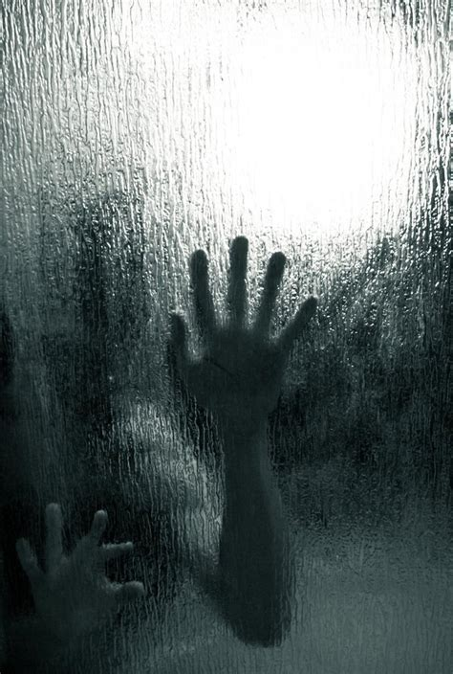
4. (2 pts.) How are fairy tales real?
   1. Many fairy tales can be assumed to be based on true events and people from history. Stories passed along through time about peoples lives that were worth remembering and creating a tale from. Now modernly changed into tales of princesses and happily ever after stories that probably didn’t end so gracefully. The story of snow white can be compared to a few women who had a hard upbringing with a ‘evil’ stepmother driving her away from home. Many other stories can be compared to lives of those from long ago.